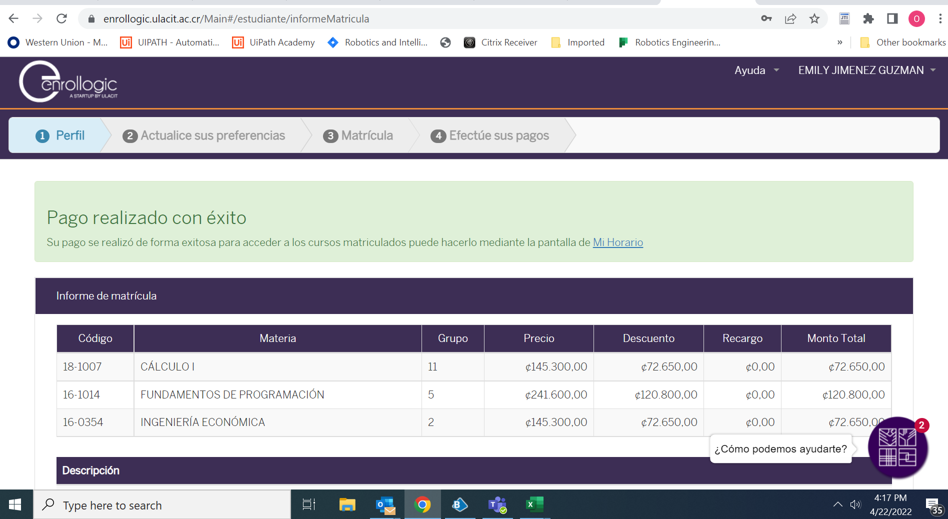<https://wuprod.service-now.com/hr?id=kb_article&sys_id=8ae00ad19706c99482a3bec3f153af72>